Hello from Santo Domingo:
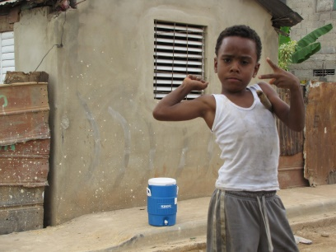

I am happy to tell you all that we are all here safe and sound in the Dominican Republic. We really had no issues getting through customs and besides a bit of sickness on the first leg of the journey…everyone is well.
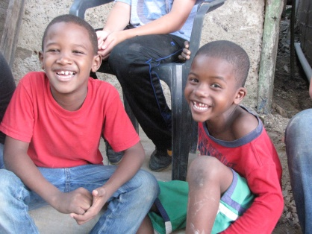
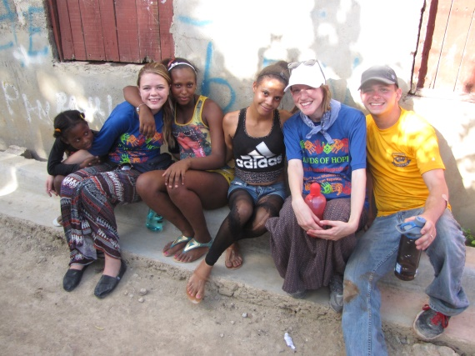
I have to say that this is an absolutely beautiful country. We had our first day in the community together and the people we have met in El Almirante aka “The Hole” are equally as beautiful. We were welcomed graciously and with great joy. The entire neighborhood (mostly kids) flocked to us and kept us company through every task we did including the construction of bathrooms, VBS, basketball (see picture), and home visits. Of course, everyone fell in love with the children of the neighborhood. They loved the attention and love that our team gave them. We are all learning some names and getting to know them as you will be able to see in many of the pictures. We are all pretty amazed at how the community k nows everyone and are always outside visiting like neigh bors do!
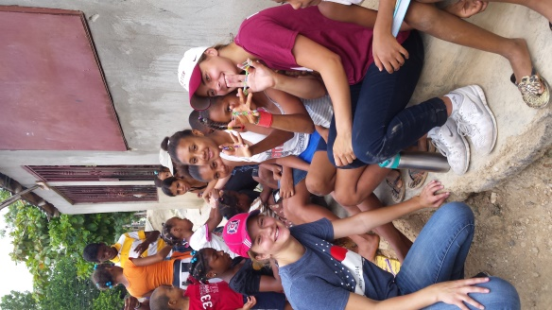
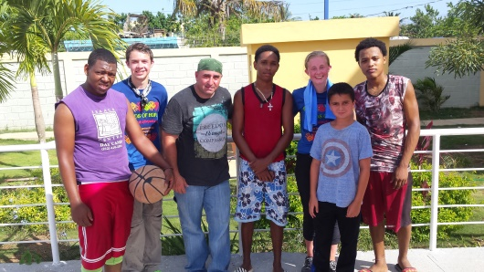
I believe that many of the people ar e outside due to the heat, which was amazing even for me who loves heat. The humidity must have been about 80% today along with temperatures in the high 80s. This made for a very sweaty team, but absolutely full of joy. Everyones’ attitudes have been phenomenal! I also want to mention that our adult chaperones have been outstanding…going the extra mile to serve our team, praying for individual team members that are struggling through some issues, and keeping smiles on their faces (Thanks to Mary Alice, Heidi, Grayson, Sara, and Beth).
Pastor Derick and I are so impressed with this team. We have had 2 very long days, but have had multiple conversations to one another sharing about how hard they have worked already, how much God is already doing among our team and in the El Almirante community. As we shared tonight in our debriefing session, it was so great to hear hearts moved already. God is clearly just getting started with our team. Please continue to pray for us as leaders, the team, energy, the El Almirante community, and mostly that God is glorified in all we do.
Pastor Ryan

