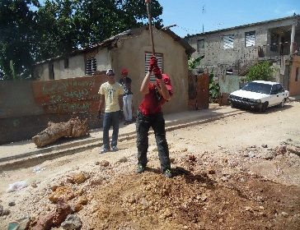
Hola from Santo Domingo…Day 2!
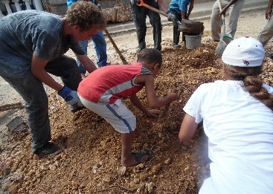
Just like yesterday we woke early to prepare our hearts minds and…stomachs for the work ahead. As we set out for El Almirante it sank in a little more that this…is…REAL. One day in the community can be easily dismissed as a dream, or mirage, but we went back again and this time we weren’t able to make the same rationalizations. Ryan and I have both been amazed out how this realization gave our team even more of a sense of mission and urgency to our work. It was H.O.T. today with air that seemed drinkable through most of the day. Yet this didn’t seem to deter anyone from upping their effort from yesterday!
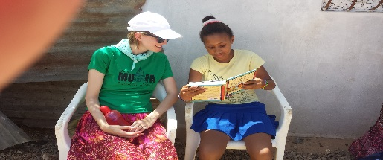
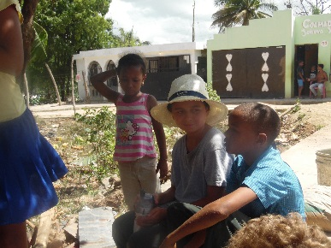
The children of El Almirante knew to expect us today and took every opportunity to hang out with their new American friends. It’s hard to put in words the range of emotions that everyone is processing through but I think that this quote from someone on the team sums it up. “I think that farm animals in America have better living conditions than these children” The students and adults alike on our team were eager to soak up every moment with these little ones to love them and point them to the one who loves them even more!
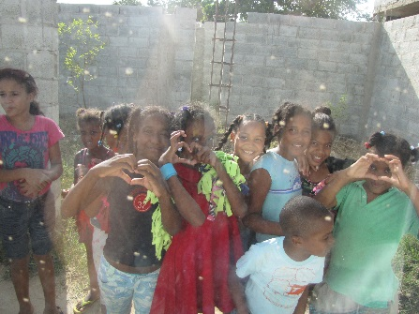
A portion of our team was able to do home visits in the morning and Matayla was able to do a very special one. She went to spend time with the child that her family sponsors. Marilu was so thrilled to receive a gift from Matayla that she even cherished the wrapping paper and ribbon! That sort of thankfulness and appreciation was evident in every child that we have met here so far. It has been incredibly humbling and convicting when we think about all of the things that we take for granted and all of the relationships that we don’t develop, and then look at how the children respond to a high five from one of us.
The team has learned a ton about the culture of the community and of past projects completed by hands of hope teams. It’s hard to believe that 3 years ago the community didn’t have any running water. Thank you Martires, Vikki, and the rest of the Hands of Hope team for giving us this awesome opportunity to be a part of what is being accomplished over the long run!

With exhausted appreciation,
Pastor Derick

