We miss you all, but we’re having a great time….
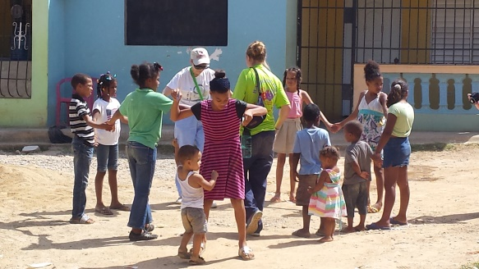
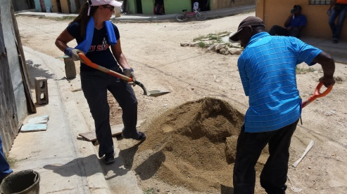
Day 3 in the community was fantastic. We are all tired from very full days physically, emotionally, and spiritually. However, with the huge help of all your prayers, we are all going strong with excitement to see our new friends in the community. Many of us are really starting to develop some relationships, even after only 3 days! The children of the community gravitate to the youth! It is so much fun to watch. Pastor Derick and I love sharing with one another how we are seeing our whole team grow, step out of their comfort zones, and let God do His thing with them and the people of the community.
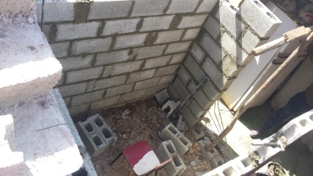
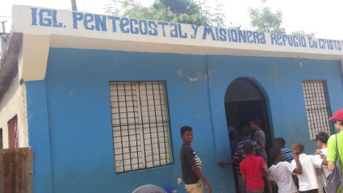
I asked my son, Kaden, today what were the main things he noticed that were very different about the Dominican Republic and back home. Things you might guess came out of his mouth including the crazy driving here, the awesome fresh tropical fruit we get to eat, and the heat. However, he also said this, “It seems like the people here have more joy than we do back home.” I thought that was an excellent and very eye opening observation considering all that God has given us! Many more thoughts, emotions, and feelings are running through all of our heads here. We are slowly processing everything we are experiencing, but the process will continue well after we are back in Madison and even beyond. Please pray for all of us as God works in each of us in dealing with this amazing journey we are on here.
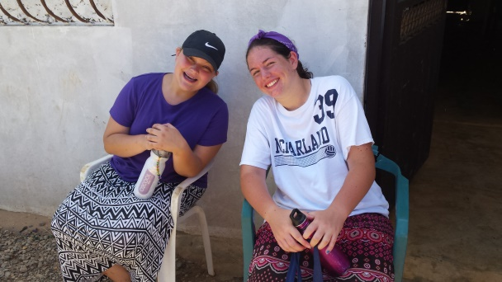
More bathroom construction, home visits (including some “adopted” children by our team members), and VBS happened today. So many great memories and relationships are being made while sweating like we have just taken a shower. I knew it was hot out when I heard our local translators say, “Wow, it’s hot out here!”
Each day it has gotten harder and harder to say goodbye to the people of the El Almirante community. Stronger bonds are being formed that language barriers don’t stand up to. I have watched most of our team that don’t know any Spanish, work very hard at learning so they can communicate with their new friends here. I can’t imagine how hard it will be to leave the community on our last day there, Sunday. God is truly good all the time. I love that He never ceases to show me that.
Sincerely,
Pastor Ryan

