Greetings from the tired intern!
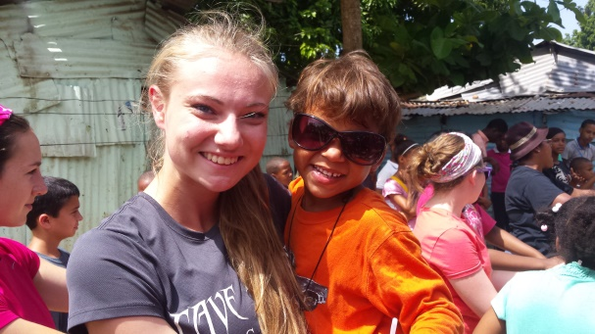
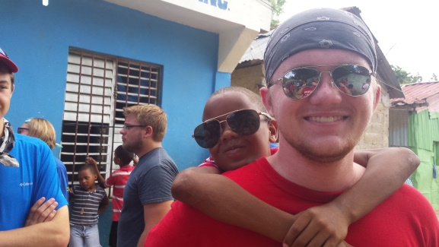
Day 4 was different than the previous three days here. We didn’t do construction, or home visits, or VBS or any of the stuff we had done before. In the morning we had a foot washing where we all washed the feet of the children in the community, like Jesus did with his disciples. This was a simple but powerful event for both us and the children.
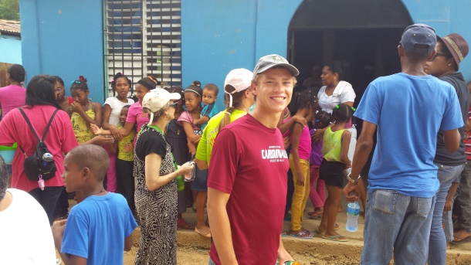
I could tell that God was really going to use this event with the amount of spiritual warfare we encountered on this day more than any other day. There were emotions that started to come and logistical issues that kept coming up, and I could tell that Satan was just trying to mess this day up. We could see on the faces of the kids how much this meant to them and loved they felt. And just hearing our students talk about it, I could tell they were so touched as well.
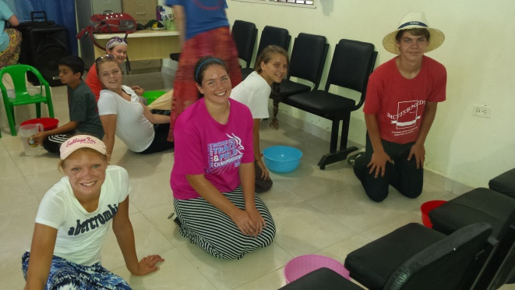
One of the things that came up during our debrief tonight was that we are starting to realize that we are leaving the community tomorrow. Almost every one of us talked about the difficulty we know we will face tomorrow in having to say goodbye to the community and the relationships that we have built. One of them described it as “love at first sight”. It is going to be incredibly hard, and an incredibly growing experience for all of us.
God’s love is being expressed in so many different ways, it continues to amaze me. He is moving, He is making himself known, and He is changing hearts.
Sincerely,
Grayson Lins, High Point Intern

